Order Of Service

Singing: Psalm 27—CW page 75

Reading: Psalm 106:19-23

Opening Hymn: CW 363

Reading: Acts 23:23-35

Request Hymn: CW Supplement 702

Reading: Matthew 10:24-33

Sermon Hymn: CW 234

Sermon Text: Mark 10:1-12

From The Beginning

Prayer

The Apostles’ Creed, TLH page 12

Holy Communion

The Lord's Prayer

The Blessing

Closing Hymn: CW 327

* * * * * * * * * * *

Koinonia Hour

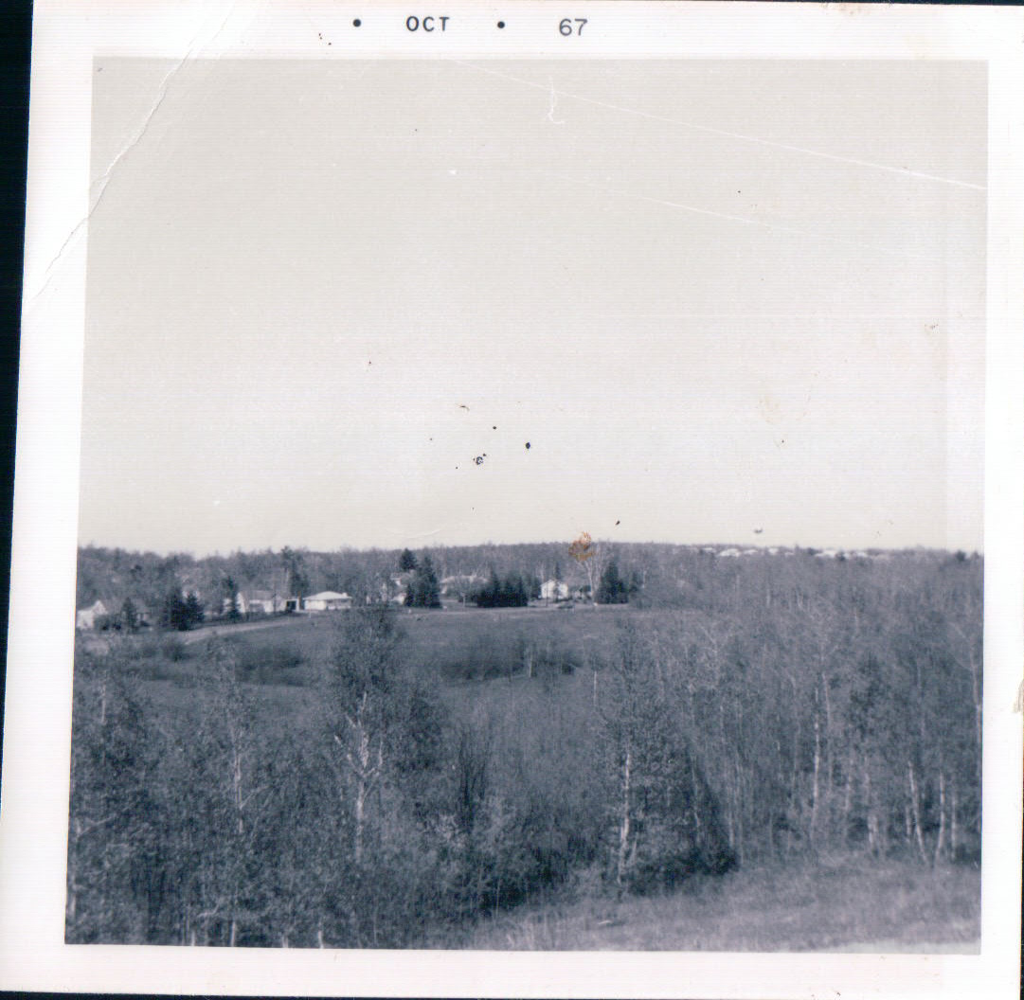

Future Home Of Shepherd Of The Hills

Duluth, Minnesota

Water
Of
Life
6 October 2019

W A T E R O F L I F E

Independent Christian Church—Conservative Lutheran Doctrine

Worship Service: 9:30 a.m. Bible Study: 10:45 a.m.

Larry Cooper, Pastor E-Mail address:
111 N. Ridge Road lcooper@wateroflife.cc
Coon Valley, WI 54623 Web Site:
www.wateroflife.cc

* * * * * * * * * * * * * * * * * * * * * * * * * * *

Sermon Text: Mark 10:1-12

From The Beginning

* * * * * * * * * * * * * * * * * * * * * * * * * * *

Mark 10:1 And he arose from thence, and cometh into the coasts of Judaea by the farther side of Jordan: and the people resort unto him again; and, as he was wont, he taught them again.
:2 And the Pharisees came to him, and asked him, Is it lawful for a man to put away his wife? tempting him.
:3 And he answered and said unto them, What did Moses command you?
:4 And they said, Moses suffered to write a bill of divorcement, and to put her away.
:5 And Jesus answered and said unto them, For the hardness of your heart he wrote you this precept.
:6 But from the beginning of the creation God made them male and female.
:7 For this cause shall a man leave his father and mother, and cleave to his wife;
:8 And they twain shall be one flesh: so then they are no more twain, but one flesh.
:9 What therefore God hath joined together, let not man put asunder.
:10 And in the house his disciples asked him again of the same matter.
:11 And he saith unto them, Whosoever shall put away his wife, and marry another, committeth adultery against her.
:12 And if a woman shall put away her husband, and be married to another, she committeth adultery.

